Year level - 3 & 4 K-6 Unit 1 |  |  |  |  |  |  |  | Unit Title – Examining and creating imaginative literary texts |  |  | Duration of Unit – Term 4– 10 Weeks
 |  |  |  |  |  |  |  | Year 4
Overview of Unit |  |  |  |  |  |  |  | Students engage with a variety of texts for enjoyment, including short chapter fiction books, picture books, print, digital and oral texts. Texts include classic or contemporary literature by Australian and world authors, including texts from and about Asia, and the oral narrative traditions and literature of First Nations Australians. Texts describe sequences of events and unusual happenings, and support or extend students as independent readers.  Students describe how ideas are developed through characters and events and how texts reflect contexts.  Students use these texts as models to create imaginative adaptations of a narrative and discuss their ideas.
Assessment (summative) – what is being assessed |  |  |  |  |  |  |  | Assessment: 1.1  Responding to literature  Assessment purpose: To read, view and comprehend an imaginative text. To create a written and/or multimodal imaginative text developing storylines, characters and settings.
Achievement Standard –  The bolded coloured aspects of the achievement standard are summatively assessed in this unit. Monitoring strategies for this unit have been identified in the underlined achievement standard aspects. |  |  |  |  |  |  |  | Year 4  Speaking and listening  By the end of Year 4, students interact with others, and listen to and create spoken and/or multimodal texts including stories. They share and extend ideas, opinions and information with audiences, using relevant details from learnt topics, topics of interest or texts. They use text structures to organise and link ideas. They use language features including subjective and objective language, topic-specific vocabulary and literary devices, and/or visual features and features of voice.  Reading and viewing  They read, view and comprehend texts created to inform, influence and/or engage audiences. They describe how ideas are developed including through characters and events, and how texts reflect contexts. They describe the characteristic features of different text structures. They describe how language features including literary devices, and visual features shape meaning. They read fluently and accurately, integrating phonic, morphemic, grammatical and punctuation knowledge.  Writing and creating  They create written and/or multimodal texts including stories for purposes and audiences, where they develop ideas using details from learnt topics, topics of interest or texts. They use paragraphs to organise and link ideas. They use language features including complex sentences, topic-specific vocabulary and literary devices, and/or visual features. They write texts using clearly formed letters with developing fluency. They spell words including multisyllabic and multimorphemic words with irregular spelling patterns, using phonic, morphemic and grammatical knowledge.
 |  |  |  |  |  |  |  | Year 4
Content descriptions that guide teaching and learning leading to the assessment |  |  |  |  |  |  |  | Language  Language for interacting with others  - explore language used to develop relationships in formal and informal situations (AC9E4LA01) Monitoring strategy – Speaking and listening  - identify the subjective language of opinion and feeling, and the objective language of factual reporting AC9E4LA02  Text structure and organisation  - identify how texts across the curriculum have different language features and are typically organised into characteristic stages depending on purposes (AC9E4LA03) Reading & viewing Writing & creating  - identify how text connectives—including temporal and conditional words—and topic word associations are used to sequence and connect ideas (AC9E4LA04) Reading & viewing Writing & creating  - identify text navigation features of online texts that enhance readability including headlines, drop-down menus, links, graphics and layout AC9E4LA05 Reading & viewing  Language for expressing and developing ideas  - understand that complex sentences contain one independent clause and at least one dependent clause, typically joined by a subordinating conjunction, to create relationships such as time and causality (AC9E4LA06) Writing & creating  - investigate how quoted (direct) and reported (indirect) speech are used (AC9E4LA07) Writing & creating  - understand how adverb groups/phrases and prepositional phrases work in different ways to provide circumstantial details about an activity (AC9E4LA08) Writing & creating  - understand past, present and future tenses and their impact on meaning in a sentence (AC9E4LA09) Writing & creating  - explore the effect of choices when framing an image, placement of elements in the image and salience on composition of still and moving images in texts AC9E4LA10 Reading & viewing Writing & creating  - expand vocabulary by exploring a range of synonyms and antonyms, and using words encountered in a range of sources (AC9E4LA11)  - understand that punctuation signals dialogue through quotation marks and that dialogue follows conventions for the use of capital letters, commas and boundary punctuation (AC9E4LA12) Writing & creating Monitoring strategy -Reading & viewing

Literature

Literature and contexts
- recognise similar storylines, ideas and relationships in different contexts in literary texts by First Nations Australian, and wide-ranging Australian and world authors (AC9E4LE01) Reading & viewing

Engaging with and responding to literature
- describe the effects of text structures and language features in literary texts when responding to and sharing opinions (AC9E4LE02)

Examining literature
- discuss how authors and illustrators make stories engaging by the way they develop character, setting and plot tensions (AC9E4LE03) Reading & viewing

- examine the use of literary devices and deliberate word play in literary texts, including poetry, to shape meaning (AC9E4LE04) Reading and viewing Monitoring strategy -Speaking & listening

Creating literature
- create and edit literary texts by developing storylines, characters and settings (AC9E4LE05) Writing & creating Monitoring strategy -Speaking & listening

Literacy
Texts in context
- compare texts from different times with similar purposes and audiences to identify similarities and differences in their depictions of events (AC9E4LY01) Reading and viewing
Interacting with others
- listen for key points and information to carry out tasks and contribute to discussions, acknowledging another opinion, linking a response to the topic, and sharing and extending ideas and information (AC9E4LY02) Monitoring strategy -Speaking & listening
Analysing, interpreting and evaluating
- identify the characteristic features used in imaginative, informative and persuasive texts to meet the purpose of the text (AC9E4LY03)Reading and viewing
- read different types of texts, integrating phonic, semantic and grammatical knowledge to read accurately and fluently, re-reading and self-correcting when needed (AC9E4LY04) Reading and viewing Monitoring strategy -Reading & viewing
- use comprehension strategies such as visualising, predicting, connecting, summarising, monitoring and questioning to build literal and inferred meaning, to expand topic knowledge and ideas, and evaluate texts (AC9E4LY05) Reading and viewing Monitoring strategy -Speaking & listening

Creating texts
- plan, create, edit and publish written and multimodal imaginative, informative and persuasive texts, using visual features, relevant linked ideas, complex sentences, appropriate tense, synonyms and antonyms, correct spelling of multisyllabic words and simple punctuation (AC9E4LY06) Writing and creating
- plan, create, rehearse and deliver structured oral and/or multimodal presentations to report on a topic, tell a story, recount events or present an argument using subjective and objective language, complex sentences, visual features, tone, pace, pitch and volume (AC9E4LY07) Monitoring strategy -Speaking & listening
- write words using clearly formed joined letters, with developing fluency and automaticity (AC9E4LY08)
Phonic and word knowledge
- understand how to use and apply phonological and morphological knowledge to read and write multisyllabic words with more complex letter combinations, including a variety of vowel sounds and known prefixes and suffixes (AC9E4LY09) Monitoring strategy -Reading & viewing
- understand how to use knowledge of letter patterns, including double letters, spelling generalisations, morphological word families, common prefixes and suffixes, and word origins, to spell more complex words (AC9E4LY10)
- read and write high-frequency words including homophones and know how to use context to identify the correct spelling (AC9E4LY11) Monitoring strategy -Reading & viewing

Moderation – identify opportunities to moderate at multiple junctures (when/who with/ what / next steps etc) | Before (before assessment takes place and at the planning stage)  Week 5  (Week 8 Term 3)  Aligning targeted aspects of the achievement standard being assessed with appropriate curriculum elements.  Calibrating understandings about how to make judgements using sample student or teacher created sample responses to summative assessment.  Quality assuring the teaching and learning sequence and reviewing the selection of pedagogical approaches, practices and teaching strategies to differentiate teaching and learning. |  |  |  |  |  |  |  | End (Engaging in moderation processes at the End of the reporting period.)  Calibrating judgements for reporting by grading sample assessment folios, representing evidence at, above and below the ‘C’ standard.  Confirming judgements for reporting by moderating sample student assessment folios, representing evidence at ‘A’, ‘B’, ‘C’, ‘D’, ‘E’ (or equivalent) level of achievement – against the targeted aspects of the achievement standard taught and assessed in the reporting period.  Using calibrated and confirmed understandings about making standards-based judgements on folios to ensure accuracy of judgements for reporting on student achievement for all students.
Week 3 – Monday Moderation of Unit 3 task
Coominya SS 3:30pm

Week 5 – Moderation /negotiated time

Calibrating understandings about how to make judgements using sample student or teacher created sample responses to summative assessment

 |  |  |  |  |  |  | What do my students need to be able to do?

Year 3 Do (Skills / Application)
READING AND VIEWING
• Read, view and comprehend texts and explain their purpose and audience.
• Identify and explain literal and inferred meaning while reading.
• Describe how a story develops by explaining how characters and/or events contribute to the plot.
• Read multisyllabic words fluently using phonic, morphemic and grammatical knowledge.

SPEAKING AND LISTENING
• Interact with others appropriately during spoken and multimodal activities (as part of the monitoring focus).
• Listen to and create spoken or multimodal stories to share ideas.

WRITING AND CREATING
• Create written and/or multimodal texts to inform, narrate, explain or argue, including relevant details from learnt topics, topics of interest or studied texts.
• Use paragraphs to organise ideas clearly.
• Use compound sentences, topic-specific vocabulary, and simple literary devices to enhance meaning.

Year 4 Do (Skills and Application)
READING AND VIEWING
• Read, view and comprehend an unfamiliar imaginative text.
• Identify the text’s purpose and explain how it engages the audience.
• Describe how ideas are developed through characters, events and context, using evidence.
• Read aloud fluently, self‑monitoring and self‑correcting when needed.
• Answer comprehension questions showing literal and inferred understanding.

SPEAKING AND LISTENING
Discuss story adaptation ideas with a partner or group.
• Listen to others' ideas and respond appropriately.
• Verbally create a spoken version of their story adaptation.

WRITING AND CREATING
Plan an imaginative adaptation, selecting a character, setting or event to change.
• Identify where the adaptation fits within the narrative sequence.
• Write a cohesive imaginative adaptation for a purpose and audience.
• Use paragraphs, varied sentences, precise vocabulary and engaging language features.
• Maintain the narrative context and author’s style.
• Review and edit for meaning, cohesion, vocabulary, punctuation and structure.
• Publish and illustrate the final version (optional).
Students below |  |  |  |  |  |  |  |  |  | Students above
 |  |  |  |  |  |  | 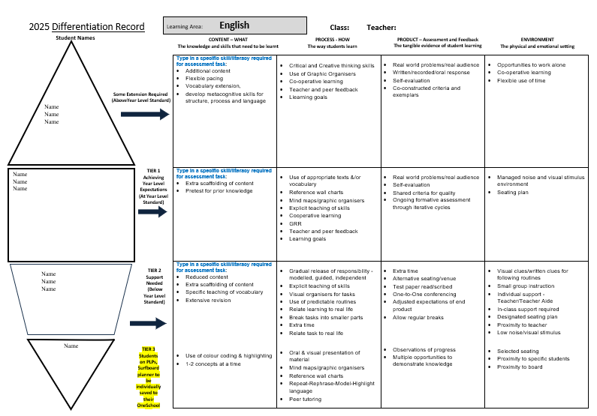
Types of special provision:
Special provisions in the conditions of assessment may include…
• presentation – changing how an assessment appears or is communicated to a student from the regular format. E.g. being read to rather than reading unless reading itself is what is being assessed.
• response – allowing students to complete assessments in different ways such as using computer software or an assistive device to solve and organise problems when this does not compromise what is specifically being assessed.
• setting – changing location including the physical or social conditions in which the assessment is completed.
• timing – allowing the student a longer time to complete the assessment, or change the way the time is organised or when the assessment is scheduled.

10 week cycle | Teaching and Learning Sequence |  |  |  | Strategies | Reading |  |  | Differentiation |  |  | Resources
Week 1  Sequence 1 | Learning Objective: I can explain how text structures are used to organise ideas.  I will be successful when:  - I identify the orientation and its content.  - I recognise the complication.  - I explain how the complication is resolved.  Learning Objective: |  |  |  |  |  |  |  |  |  |  | Beth the story of a child convict – Mark Wilson
Week 2
Sequence 1 continued…

Week 3
Sequence 2

Week 4
Sequence 2 continued
Week 5  Sequence 3 |  |  |  |  |  |  |  |  |  |  |  | c
Week 6
Sequence 3 continued…
Week 7
Sequence 4
Week 8
Sequence 4 continued
Week 9
Sequence 5

Week 10  Sequence 5 continued.. | ^{Review}
How will I track and monitor my students’ progress throughout this unit and provide effective feedback?

Unit overview – Teaching, learning and assessment
Week 1 | Week 2 | Week 3 | Week 4 | Week 5 | Week 6 | Week 7 | Week 8 | Week 9 | Week 10
Sequence 1 |  | Sequence 2 |  | Sequence 3 |  | Sequence 4 |  | Sequence 5
Reading and viewing, Writing and creating Examining and creating imaginative literary texts
Literacy knowledge, concepts and skills
Structure:  Orientation, Complication, Conclusion | Key details and supportive description | Sentences: Simple and compound  Punctuated dialogue | Sentences: Complex | Tense | Paragraphs  Cohesive devices | Editing Skills | Yr 3 Assessment task 1.1
Context | Settings: Context description | Characters | Point of View |  |  |  | Yr 4 Assessment task 1.1
Noun groups | Precise Vocabulary – Word Wall | Noun groups  Verb groups | Adverbials, adverb groups | Prepositional Phrases | Figurative language: simile/metaphor | Figurative language: Personificationersonification

